# Technical Process

## *1. Methods, Tools, and Techniques*

In order to work with rest of the member of our team we use several app to communicate. When we need to massage someone to about something, we did use this application which is handy can be use in anywhere any time. So, for documentation we did use the google doc online. It is very easy to use and can be use both from mobile phone or laptop not need very high graphic or technology to use it and when ever we need to add something everyone can see the work and change whenever they need.

We are a team of five member need to divide all the task in very responsible way so they can work based on that and can be reached in the goal without delaying the process. Here is our scrum framework we will be working based on that throughout the semester.

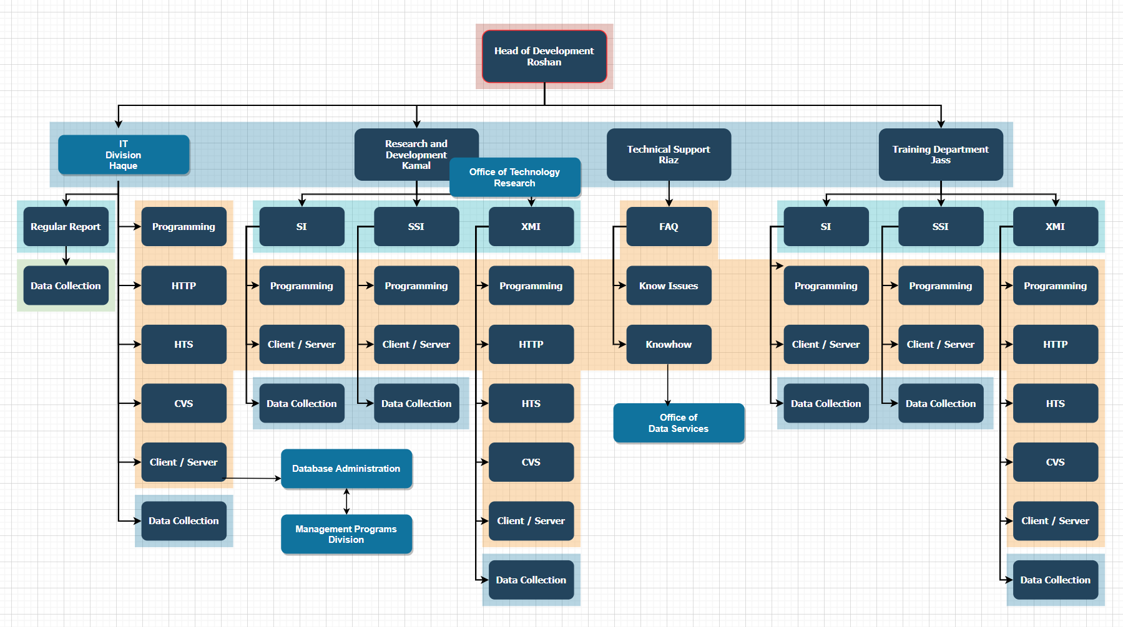

Role and position of each member in the team

For software design we use draw.io which is online based and completely free we can draw the diagram and chart very easily over there. ERD diagram, UML diagram, crow foot notation and many more diagram we will design throughout developing our project.

For document and code management we will be using GitHub and Microsoft excel and access which we have default in our laptop but for GitHub we just need to create an account to use.

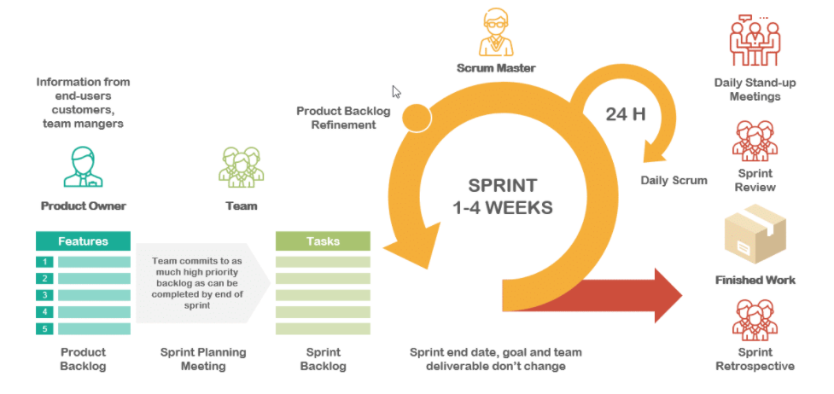

***Scrum framework***

For the last 7 week we all are working on the project plan, guild line what to do what not but from now on we will be start working on the main prototype work. we will be discussing more in the presentation demonstration.

**Communication tools:**

Throughout the course for this semester In order to finish our project we need to contact with multiple people and in the time of pandemic when its lockdown going on here, we have no option but to contact through online and here is how we maintain that with all these people.

|  |  |  |  |
| --- | --- | --- | --- |
| Contact with the group member | Contact with the client | Contact with tutor | Contact with supervisor |
| What’s app |  |  | What’s app |
| Mobile phone |  | Email | Adobe connect |
|  | Zoom | Adobe connect |  |
|  | Email |  |  |

**Tools and software use for documentation coding and tracking our work:**

For this semester to design and documenting our work for this project we have to use lots of application, tools and software some were free some we have to use our university identity, and some was trial version. Here is all of them until now we use for our project and rest of the year, we hope we will be working on those.

|  |  |
| --- | --- |
| **Software or tools** | **Uses for** |
| Microsoft team, GitHub | Tracking the work and see the progress overall. |
| MIT inventor | Interface and design the prototype. |
| Draw.io, Lucid chart | Illustrate the diagram and flowchart. |
| Python, java | Coding the programme. |
| MySQL | Design the data structure and data base. |
| JavaScript, Php, HTML | Use for designing the website and update. |
| MS word, MS PowerPoint | Documenting the idea, work and present the work. |

## *2 Software Documentation*

Technical documentation helps an intended audience use our product, understand our processes, and get unstuck. Whether that audience is end-users, administrators, colleagues, or technicians does not really matter. What does matter is that it is clear, searchable, and helpful for them.

Every technical writing project starts with research. It might sound obvious, but knowing the purpose and scope the technical documentation beforehand will save us a ton of time and energy (and headaches)

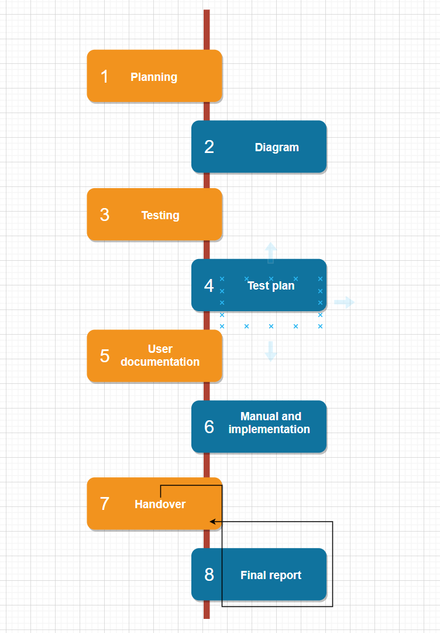

* **Existing resources** will help updating or merging current resources or starting from scratch. This Will help to find anything and everything that will make sure the accuracy our work and effort.
* **Style guides is mandatory for documentation.** This project requires us to write technical documentation in a specific way which have a style guide that explains what language to use, how to talk to users, and even grammatical styles.

## 3. Plan for creating user and technical documentation:

1. **Planning:** we know the purpose and scope of the project. This may seem obvious but spending time up front can reduce the actual writing time as well as head off costly, significant changes during the project.  We did make sure to identify goals, existing resources (internal, [contract](http://www.novatekcom.com/blog/bid/393230/www.novatekcom.com/about/contract-staffing-and-support) or [outsourcing](http://www.novatekcom.com/about/technical-writing-training-projects)), style guides, deadlines, costs, and final deliverables.
2. **Drafting:** Start with a high-level outline on all topics to be covered. Which we are doing throughout splint 1, Then, begin gathering the specific content and supporting graphics, making sure to leave placeholders for any information gaps. After drafting procedures, we are after self-review to make sure this work performs each procedure as we have written it. Above all, we are focusing that the client must be able to easily understand and navigate through the content.
3. **Reviewing:** Typically, project formal reviews take place upon completion of a first draft and a final draft. Depending on the type of content our client looking for to developing, however, we want the supervisor to check individual sections or topics. Where new product information may still be in flux, leave time for more reviews.
4. **Revising:** Now that our first draft is ready, set up a peer review to test the accuracy. Again, we try to make sure the content is presented in a way that makes sense for our client and user.

1. **Editing:** we try to turn the document over to the [technical editor](http://blog.novatekcom.com/blog/bid/295670/Technical-Writing-Services-Adding-a-Second-Set-of-Eyes), its mainly our tutor who makes sure the language has a logical flow and the content is complete and consistent. Having a second set of eyes on the content can increase both the credibility and professionalism of the entire piece.
2. **Publishing/Maintaining.** After document is signed-off by our reviewers, it’s ready for publishing. At this point, the document falls into maintenance status. Documentation must be reviewed on a regular basis by the client and supervisor and brought up to date to provide the most complete and accurate information to them. In order to, maintenance the guideline to avoid warning from the [client](http://www.novatekcom.com/blog/bid/368708/Quality-System-Documentation-Strategies-for-Surviving-an-FDA-Audit).

Our technical approach to this way documentation can help our work to reduce risk, cut costs, and improve quality.